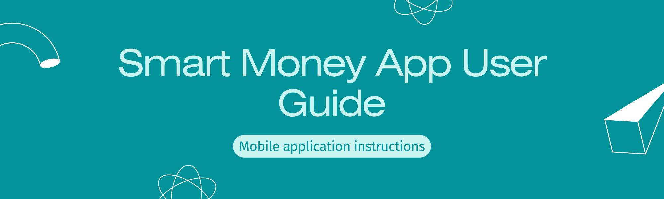
Development Environment Setup
This guide provides instructions for setting up the development environment for the Smart Money application. Please follow the steps below to ensure a successful setup.
Backend:
- Java JDK 17
- Spring Boot 3.x
Frontend:
- Node.js (v18+)
- React.JS
- Flutter SDK
Database:
- SQL Server 2022
Installation Steps
Follow these steps to install and configure each component of the Smart Money application.
Database Setup
- Install SQL Server 2022: If you haven't already, install SQL Server 2022 on your machine.
- Execute Database Script: Run the script against your SQL Server instance to create the necessary tables and schema.
Backend Configuration
- Configure : Update the file with the appropriate credentials for your Firebase project (if Firebase is used).
- Configure : Modify the file to include the correct username and password for your SQL Server instance. Ensure the database connection details are accurate.
Example :
Backend Startup
- Run : Execute the class to start the Spring Boot backend. Ensure that the application compiles and starts without errors.
Frontend: Web
- Navigate to Web Directory: Open a terminal and navigate to the web frontend directory.
- Install Dependencies: Run to install all required Node.js modules (npm install).
- Start Application: Execute to start the React.JS web application (napmrun). The application should open in your default web browser.
Frontend: Mobile (Flutter)
- Navigate to Mobile Directory: Open a terminal and navigate to the mobile frontend directory (Flutter project).
- Get Dependencies(flutter pub get): Run to install all required Flutter packages.
- Configure App Constants(ipconfig): Open the file and update the IP address to match your machine's IP address. You can find your IP address using the command (on Windows) or command (on Linux/macOS).
- Update Firebase Project:
  - Run in the directory of your Flutter project to get the SHA1 and SHA-256 keys.
  - Add the SHA1 and SHA-256 keys to your Firebase project settings for Android.
  - Download the updated file from Firebase.
  - Replace the existing file in your Flutter project's directory.
- Run Application(flutter run): Connect a physical device or start an emulator, and then run to start the Flutter mobile application on your device.
Smart Money App – User Guide (Mobile Application)
1. LOGIN & REGISTER PAGE
Figures:
- Figure 33.1: LOGIN VIEW
- Figure 33.1: REGISTER VIEW
Login Page Instructions:
- Enter your email or phone number.
- Enter your password.
- Tap the Login button to access your account.
- You can also log in with your Google account.
- Tap the eye icon to show or hide your password.
- If you forget your password, select “Forgot Password” to reset it.
- You can log in using fingerprint or facial recognition if enabled.
- If you don’t have an account, tap “Create Account” to register.
- For help, tap “Support” to contact assistance.
Register Page Instructions:
- Enter your email address.
- Enter your phone number.
- Create a password.
- Re-enter your password for confirmation.
- Tap Register to create your account.
- You can also sign up with Google.
2. OVERVIEW PAGE
Figure: Figure 34: Overview Page
Purpose: Displays a summary of your financial status.
Instructions:
- View the balance of the selected wallet.
- Tap to select a wallet.
- Filter data by day, week, month, quarter, or year.
- View total income, total expenses, and net amount.
- Analyze your cash flow trend chart.
- Review your spending chart by category.
- Identify the category with the highest spending.
- Check your recent transaction history.
3. TRANSACTION PAGE
Figure: Figure 35: Transaction Page
Purpose: Manage your income and expense transactions.
Instructions:
- View all transactions sorted by date or category.
- Tap “+” to add a new transaction.
- Filter transactions by wallet, category, or date range.
- Edit or delete existing transactions as needed.
4. WALLET SELECTION PAGE
Figure: Figure 36: Wallet Selection Page
Instructions:
- Choose from your list of wallets (e.g., Cash, Bank Account, E-Wallet).
- Tap a wallet to view its details and balance.
- Add a new wallet if needed.
5. TRANSACTION CREATION PAGE
Figure: Figure 37: Transaction Creation Page
Instructions:
- Select wallet and category.
- Enter amount, date, and note.
- Choose income or expense type.
- Tap Save to record the transaction.
6. BUDGET PAGE
Figures:
- Figure 38: Budget Page
- Figure 39: Add Budget Page
- Figure 40: Budget Information Page
- Figure 41: Edit Budget Page
Instructions:
- View all your active budgets.
- Tap Add Budget to create a new one.
- Enter amount, start date, end date, and categories.
- Monitor spending progress and remaining budget.
- Edit or delete budgets as needed.
7. ACCOUNT PAGE
Figure: Figure 42: Account Page
Instructions:
- View and update your profile information.
- Change your password.
- Manage notifications and preferences.
- Log out from your account.
8. MY WALLET PAGE
Figures:
- Figure 43: Wallet View Page
- Figure 44: Choose Wallet to Create Page
Instructions:
- View all wallets with their current balances.
- Tap a wallet to see detailed transactions.
- Create a new wallet by selecting “Add Wallet” and entering wallet details.
9. CATEGORY PAGE
Figure: Figure 45: Category Page
Instructions:
- View all income and expense categories.
- Add, edit, or delete categories.
- Assign categories to transactions for better tracking.
10. EVENT PAGE
Figure: Figure 46: Event Page
Instructions:
- Create and manage financial events (e.g., trips, weddings).
- Track expenses and budgets for each event.
- Mark events as completed when finished.
11. RECURRING TRANSACTIONS PAGE
Figure: Figure 47: Recurring Transactions Page
Instructions:
- View all scheduled recurring transactions.
- Add new recurring payments (e.g., rent, subscriptions).
- Edit or cancel recurring transactions.
12. INVOICE PAGE
Figure: Figure 48: Invoice Page
Instructions:
- View and manage invoices or receipts.
- Upload images of receipts for record-keeping.
- The system can extract data using OCR (Optical Character Recognition) for automatic entry.
Summary
The Smart Money App provides a complete personal finance management experience, allowing users to:
- Track income and expenses
- Manage multiple wallets
- Set and monitor budgets
- Create saving goals and events
- Receive notifications and reports
Next Steps
After completing the setup and installation, you can now start using the Smart Money application for your personal finance management needs. Refer to the user guide for more details on how to use the app effectively. If you encounter any issues, consult the troubleshooting documentation or contact support for assistance.

